WEEK 3 OF 12 | LABORATORY HANDOUT
Lab 3: Advanced Trees
AVL trees, Red-Black tree concepts and BST performance
Goal of this lab: see a plain BST collapse into a linked list, build the machinery that prevents it (rotations and an AVL tree), learn to read and check Red-Black trees, and measure the difference with real timings.
Duration | 75 minutes in the lab (Parts A to E) + mini challenge (homework, about 2 hours)
Language | Python 3.10 or newer; matplotlib for the two plots in Part E
Files you receive | week3_lab_starter.py (skeleton + automatic tests, listed in Appendix A) and rbtree.py (reference Red-Black tree, Appendix B)
Prerequisites | Week 3 lecture; Week 1 (big-O) and Week 2 (recurrences, divide and conquer)
Work mode | Individual coding; you may discuss the paper exercises with your neighbour
Submission | One ZIP: your completed .py file(s), the results sheet (Section 9) and two plots. Deadline: before the Week 4 lecture

1. Learning objectives
By the end of this lab you should be able to:
- Demonstrate that a plain binary search tree built from sorted keys has height n - 1, and explain why every operation then costs O(n).
- Implement left and right rotations and prove, by testing, that they preserve the in-order sequence of keys.
- Trace AVL insertions by hand, naming the unbalanced node, its balance factor and the case (LL, RR, LR or RL) at each step.
- Implement an AVL tree with rebalancing and a validator that checks order, stored heights and balance factors.
- Check whether a coloured tree satisfies the five Red-Black properties, and trace Red-Black insertions through Cases 1 to 3.
- Benchmark a plain BST, an AVL tree, a Red-Black tree and a sorted Python list, and interpret the results in terms of big-O and constant factors.

Lab plan
Part | Topic | Time | Marks
A | Plain BST and degeneration | 15 min | 15
B | Rotations | 10 min | 10
C | AVL tree: hand trace and implementation | 25 min | 30
D | Red-Black trees: classify, trace, validate | 10 min | 15
E | Benchmarking and interpretation | 15 min | 20
Report | Results sheet, plots and short answers | homework | 10
Challenge | Order-statistic AVL leaderboard (200,000 players) | homework | +10 bonus

2. Before you start
- Create a folder lab3 and copy week3_lab_starter.py and rbtree.py into it. If you only have this handout, type the code from Appendices A and B.
- Open a terminal in that folder and run python week3_lab_starter.py. You should see four lines that start with TODO. Each line turns into PASS as you complete a part.
- Install matplotlib if you do not have it: pip install matplotlib.
- Keep the results sheet (Section 9) open: you will fill it in as you go.
RULES FOR THIS LAB
Do not import any tree library. bisect and random from the standard library are allowed.
The plain BST must be iterative. A recursive version crashes on sorted input, which is one of the things you will observe in Part A.
Heights are measured in edges: a single node has height 0 and an empty tree has height -1.
Test after every function. The automatic tests at the bottom of the starter file are the minimum; add your own.

3. Part A: plain BST and degeneration (15 min)
A binary search tree keeps every key in a node's left subtree smaller than the node and every key in the right subtree larger. Search, insert and delete follow a single root-to-leaf path, so they all cost O(h), where h is the height. The shape, and therefore h, depends entirely on the order in which keys arrive. In this part you will measure how bad that can get.
A1 Complete BST.insert(key) without recursion. Walk down from the root with a while loop and attach the new node where you fall off the tree. Ignore duplicate keys. [4 marks]
A2 Complete BST.search(key), also iteratively. Return True or False. [2 marks]
A3 Complete BST.height(). It must work on a chain of 8,000 nodes, so use an explicit stack or a queue (level-order) instead of recursion. [3 marks]
Hint for A3: push pairs (node, depth) onto a list used as a stack; the answer is the largest depth you pop.
A4 Experiment. For n = 100, 500, 1,000, 2,000 and 5,000, build one BST from the keys 0 .. n-1 in sorted order and one from the same keys shuffled with random.shuffle. Record both heights in Table 1 of the results sheet together with the ceiling of log2 n. [4 marks]
A5 Write a recursive insert function (it takes a node and a key and returns the subtree root) and use it to insert 0, 1, 2, ... 1,999 in order. What happens, after roughly how many keys, and why? Which Python setting is involved? [2 marks]
THINK ABOUT IT
Random insertion order gives a height of roughly 3 log2 n on average, but that is only an average-case promise about the input. Real inputs are often sorted or nearly sorted: auto-increment IDs, timestamps, alphabetical lists. Part C removes the dependence on luck.

4. Part B: rotations (10 min)
A rotation is a local restructuring that moves one node up and its parent down while keeping the BST order. It changes three pointers, so it costs O(1) no matter how large the subtrees T1, T2 and T3 are.
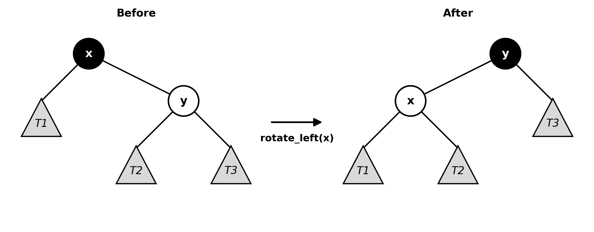
Figure 1. Left rotation at x: y moves up, x moves down to the left, and subtree T2 changes parent.
B1 Complete the stand-alone function rotate_left(x) in the starter file. It returns the new subtree root y. [3 marks]
B2 Complete rotate_right(y), the mirror image. The test rotates the root of 100 random trees and checks that the in-order sequence is unchanged. [3 marks]
B3 On paper: the tree 8(3(1, 6), 10(-, 14)) has root 8, left child 3 (children 1 and 6) and right child 10 (right child 14). Draw the tree after rotate_left at 8, then write its in-order sequence. Which subtrees moved up a level and which moved down? [2 marks]
After left rotation: 10(8(3(1, 6), —), 14). The in-order sequence is 1, 3, 6, 8, 10, 14. Node 10 and its right subtree 14 move up one level; node 8 and its left subtree rooted at 3 move down one level. The middle subtree T2 is empty here.

B4 In one or two sentences: why can a rotation never break the BST property? (Hint: list the in-order sequence T1, x, T2, y, T3 before and after.) [2 marks]
Before and after a left rotation the in-order sequence is T1, x, T2, y, T3. Since T2 lies between x and y in key order, reattaching it as x.right preserves every BST ordering constraint; the right rotation is symmetric.

5. Part C: AVL tree (25 min)
An AVL tree is a BST in which, at every node, the heights of the left and right subtrees differ by at most one. The balance factor is BF(n) = height(n.left) - height(n.right) and must be -1, 0 or +1. After an insertion, walk back up the path; at the lowest node whose BF has become +2 or -2, apply one of four fixes.
Case | Condition at node z | Fix
LL | BF(z) = +2 and BF(z.left) >= 0 | rotate_right(z)
LR | BF(z) = +2 and BF(z.left) < 0 | rotate_left(z.left), then rotate_right(z)
RR | BF(z) = -2 and BF(z.right) <= 0 | rotate_left(z)
RL | BF(z) = -2 and BF(z.right) > 0 | rotate_right(z.right), then rotate_left(z)

Start with the paper exercises C6 and C7: tracing by hand first makes the code much easier to write.

Paper exercises
C6 Insert 50, 40, 30, 45, 47, 20, 10 into an empty AVL tree. For each insertion, fill in one row of Table 2 on the results sheet: the unbalanced node (if any), its balance factor, the case, and the rotation(s). Draw the final tree and give its height. What height would a plain BST have for the same sequence? [6 marks]
C7 Let N(h) be the minimum number of nodes in an AVL tree of height h. Explain why N(h) = N(h - 1) + N(h - 2) + 1 with N(0) = 1 and N(1) = 2, then complete Table 3 for h = 0 .. 8. Use the recurrence to find the largest possible height of an AVL tree holding 1,000,000 keys. [4 marks]

Implementation
The starter file gives you AVLNode (with a stored height), and the helpers h(node), update(node) and balance(node). Complete the following methods of AVLTree:
C1 rotate_left(x): re-link as in Part B, then call update(x) before update(y) (x is now lower) and add 1 to self.rotations. [3 marks]
C2 rotate_right(y): the mirror image. [2 marks]
C3 rebalance(node): update the node's height, compute its BF and apply the correct case from the table above. Return the root of the subtree (which may be a different node). [6 marks]
C4 _insert(node, key): ordinary recursive BST insertion, except that every return goes through self.rebalance(node). [4 marks]
C5 is_valid(): return True only if the BST order holds (use lower and upper bounds, not just parent comparisons), every stored height equals 1 + max(h(left), h(right)), and every BF is in {-1, 0, +1}. [5 marks]
COMMON BUGS
Updating heights in the wrong order after a rotation (update the node that moved down first).
Forgetting to use the returned root: always write node.left = self._insert(node.left, key).
Mixing up the sign convention of BF. Choose left minus right, and comment it.
Only testing random input. Sorted and reverse-sorted input exercise every rotation case.

6. Part D: Red-Black trees (10 min)
A Red-Black tree is a BST whose nodes are coloured red or black so that: (1) every node is red or black; (2) the root is black; (3) every NIL leaf is black; (4) a red node never has a red child; (5) every path from a node down to a NIL leaf contains the same number of black nodes. Together these guarantee h <= 2 log2(n + 1).
In the black-and-white figures, black nodes are solid black, red nodes are light grey with a dashed outline, and NIL leaves are small black squares.
D1 For each of the four trees below, state whether it is a valid Red-Black tree. If not, name the property that is violated and the node where it happens. [4 marks]
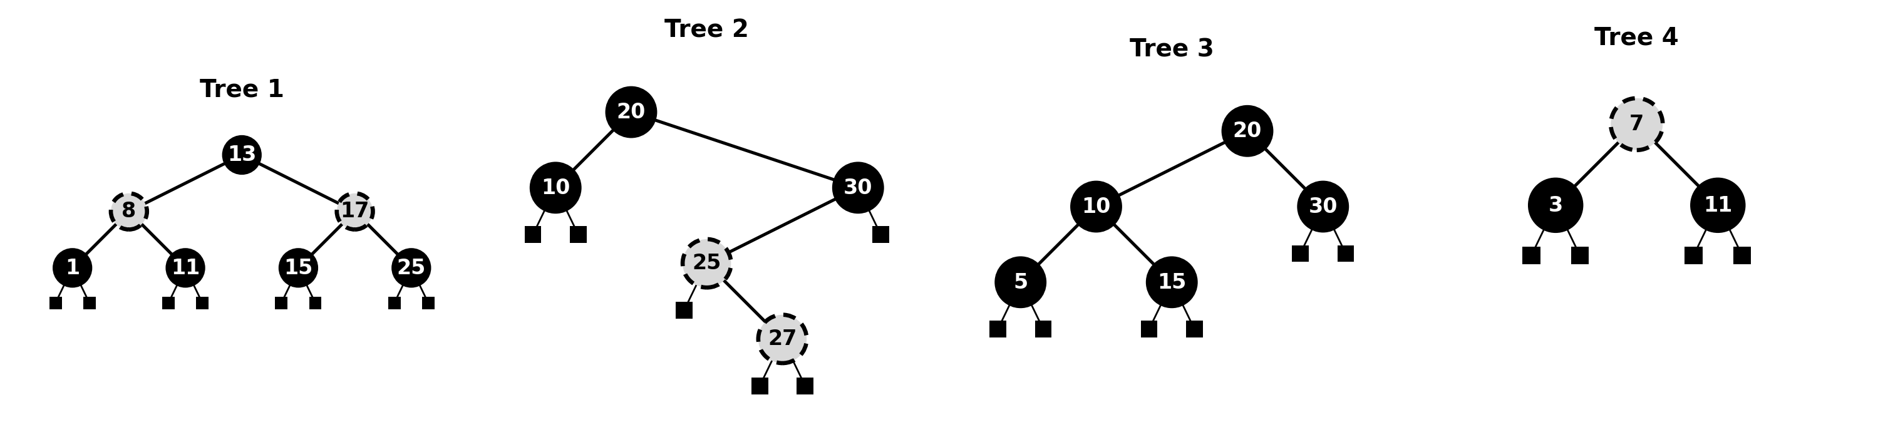
Figure 2. Classify each tree (grey dashed = red, solid = black, squares = NIL).
Tree | Valid? (yes / no) | Violated property and where
1 | Yes | None; equal black-height 3 including NIL.
2 | No | Property 4: red 25 has red child 27.
3 | No | Property 5 at 20: left black-height 4, right 3.
4 | No | Property 2: root 7 is red.

D2 Insert 41, 38, 31, 12, 19, 8 into an empty Red-Black tree. For each insertion write down which case applies (parent black: nothing to do; Case 1: uncle red, recolour; Case 2: uncle black, triangle; Case 3: uncle black, line) and draw the tree after the fix-up. Use Table 4 on the results sheet. [5 marks]
D3 Complete is_valid_rb(t) in the starter file. Trees are nested tuples (key, colour, left, right) with None for NIL. Return (True, black_height) or (False, reason). Count black nodes on a root-to-NIL path including both the root and the NIL, so Tree 1 above has black-height 3. [6 marks]
Hint: write a recursive helper that returns the black-height of a subtree and raises an exception as soon as it finds a violation; check the root colour separately.

7. Part E: benchmarking (15 min)
Big-O tells you how cost grows; a benchmark tells you what it actually costs on your machine. You will compare four structures that all support ordered insert and search:
- BST: your iterative plain BST from Part A.
- AVL: your AVL tree from Part C (recursive insertion).
- Red-Black: RBTree from the provided rbtree.py (iterative, CLRS style).
- Sorted list: a Python list kept sorted with bisect.insort; search with bisect.bisect_left.
E1 Write a function run(cls, keys) that builds a structure from keys, timing the insertions with time.perf_counter(), then times 1,000 searches for keys chosen with random.sample(keys, 1000). Return (insert ms, search ms, height). [5 marks]
E2 Run it for n = 1,000, 2,000, 4,000 and 8,000, with random and with sorted input, for all four structures. Record the n = 8,000 results in Table 5. [5 marks]
E3 Make two plots with matplotlib: (a) height against n for the three trees with random input, adding a dashed log2 n reference line; (b) height against n for sorted input (use a log scale on the y-axis). Label axes and include a legend. [4 marks]
E4 Answer in the results sheet: (a) By what factor is a search in the BST built from sorted keys slower than in the AVL tree at n = 8,000? (b) Why is the Red-Black tree taller than the AVL tree yet no slower to search? (c) The sorted list wins this benchmark. Explain why, and predict what happens to its insertion time at n = 2,000,000. [6 marks]
"""Part E benchmark; run from this folder. Reports the second of two runs."""
import bisect
import math
import random
import time
import matplotlib
matplotlib.use('Agg')
import matplotlib.pyplot as plt
from rbtree import RBTree
from week3_lab import BST, AVLTree

class SortedList:
def __init__(self): self.data = []
def insert(self, key):
i = bisect.bisect_left(self.data, key)
if i == len(self.data) or self.data[i] != key: self.data.insert(i, key)
def search(self, key):
i = bisect.bisect_left(self.data, key)
return i < len(self.data) and self.data[i] == key
def height(self): return None

def run(cls, keys, probe=None):
"""Return insertion ms, 1,000 successful-search ms, and height."""
if probe is None: probe = random.sample(keys, 1000)
t = cls()
start = time.perf_counter()
for key in keys: t.insert(key)
insert_ms = (time.perf_counter() - start) * 1000
start = time.perf_counter()
for key in probe: assert t.search(key)
search_ms = (time.perf_counter() - start) * 1000
return insert_ms, search_ms, t.height()

def main():
rng = random.Random(4263145)
results = {}
structures = (("Plain BST", BST), ("AVL tree", AVLTree),
("Red-Black tree", RBTree), ("Sorted list + bisect", SortedList))
for n in (1000, 2000, 4000, 8000):
sorted_keys = list(range(n))
random_keys = sorted_keys.copy()
rng.shuffle(random_keys)
probe = rng.sample(sorted_keys, 1000)
for order, keys in (("random", random_keys), ("sorted", sorted_keys)):
for name, cls in structures:
run(cls, keys, probe)
value = run(cls, keys, probe)
results[(n, order, name)] = value
print(f"{n:5d} {order:6} {name:20} insert={value[0]:9.3f} "
f"search={value[1]:8.3f} height={value[2]}", flush=True)
for order, filename in (("random", "height_random.png"),
("sorted", "height_sorted.png")):
fig, ax = plt.subplots(figsize=(7, 4.5))
sizes = (1000, 2000, 4000, 8000)
for name in ("Plain BST", "AVL tree", "Red-Black tree"):
ax.plot(sizes, [results[(n, order, name)][2] for n in sizes],
marker="o", label=name)
if order == "random":
ax.plot(sizes, [math.log2(n) for n in sizes], "k--", label="log2 n")
else: ax.set_yscale("log")
ax.set_xlabel("Number of keys n")
ax.set_ylabel("Tree height (edges)")
ax.set_title(f"Tree height with {order} insertion order")
ax.legend()
ax.grid(True, alpha=.25)
fig.tight_layout()
fig.savefig(filename, dpi=180)
plt.close(fig)
with open("benchmark_results.csv", "w") as out:
out.write("n,order,structure,insert_ms,search_1000_ms,height\n")
for (n, order, name), (im, sm, height) in results.items():
out.write(f"{n},{order},{name},{im:.3f},{sm:.3f},{'' if height is None else height}\n")

if __name__ == "__main__": main()
Tip: the recursive AVL insertion needs sys.setrecursionlimit(10000) only as a safety net; its depth never exceeds about 1.44 log2 n. Run each measurement twice and keep the second result to avoid start-up effects.

8. Mini challenge: a 200,000-player leaderboard
SCENARIO
An online game has 200,000 players. Scores change constantly, and the game must answer two questions instantly: "What is my rank?" and "Who is in position k?". A dictionary cannot answer either question; re-sorting a list after every score change costs O(n log n).
Extend your AVL tree into an order-statistic tree: every node also stores size, the number of nodes in its subtree. Store keys as tuples (-score, player_id) so that position 1 is the highest score and ties are broken by player id.

Requirements
- Add size to the node and maintain it wherever you maintain height (in update, therefore also in both rotations). Extend is_valid() to check sizes.
- Add delete(key) to your AVL tree (BST deletion, then rebalance on the way back up). After deletion, the heavy child can have BF 0; treat that as LL or RR.
- Implement select(k): return the k-th smallest key (0-based) in O(log n) by comparing k with the size of the left subtree.
- Implement rank(key): return the number of keys smaller than key in O(log n).
- Build a Leaderboard class with set_score(player, score), rank_of(player) (1-based) and at(position) (1-based). A score change is a delete followed by an insert.
- Load 200,000 players with random scores, then apply 100,000 random score updates and 2,000 queries. Report the times.
- Implement the same interface with a Python list kept sorted using bisect.insort, check that both leaderboards give identical answers, and compare their speed.

Questions for your report
- Which version is faster at 200,000 players? Is that what big-O predicts? Explain any surprise in terms of constant factors (what does bisect.insort actually do in memory?).
- Measure the time per update for 200,000, 1,000,000 and 2,000,000 players (fewer updates is fine). How does each version scale?
- Stretch: add top(k), returning the k best players in O(log n + k).

9. Results sheet
Name: Damir Rasmuxamedov Student ID: 4245973 Date: 28 September 2026

Table 1. Part A4: BST height by insertion order
n | Height (sorted input) | Height (random input) | ceil(log2 n)
100 | 99 | 12 | 7
500 | 499 | 17 | 9
1,000 | 999 | 20 | 10
2,000 | 1,999 | 20 | 11
5,000 | 4,999 | 28 | 13

A5: What happened with the recursive insert, and why?
With Python’s default recursion limit of 1,000, the sorted recursive insert raised RecursionError while inserting key 998 (about 1,000 keys). Each insert descends one level in the chain; the call stack eventually exceeds sys.getrecursionlimit(). The starter file raises that limit to 10,000 for its other exercises, so I reset it to 1,000 for this experiment.

Table 2. Part C6: AVL trace for 50, 40, 30, 45, 47, 20, 10
Insert | Unbalanced node | BF | Case | Rotation(s)
50 | — | — | — | None
40 | — | — | — | None
30 | 50 | +2 | LL | Right at 50
45 | — | — | — | None
47 | 50 | +2 | LR | Left at 45; right at 50
20 | — | — | — | None
10 | 30 | +2 | LL | Right at 30

Final tree (draw), its height, and the plain BST height for the same sequence:
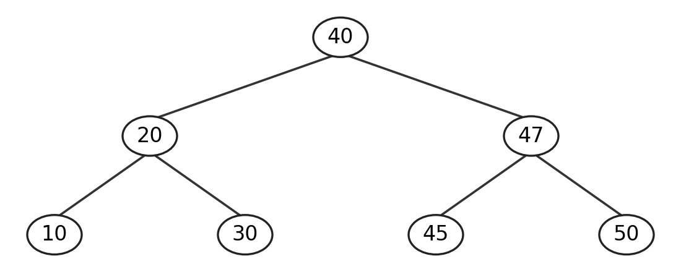
AVL height = 2 edges. Plain BST height = 4 edges (longest path 50 → 40 → 30 → 20 → 10).

Table 3. Part C7: minimum nodes of an AVL tree
h | 0 | 1 | 2 | 3 | 4 | 5 | 6 | 7 | 8
N(h) | 1 | 2 | 4 | 7 | 12 | 20 | 33 | 54 | 88

Largest possible height of an AVL tree with 1,000,000 keys: 27 Working:
Largest possible height: 27 edges. To minimize nodes at height h, one child has height h − 1 and the other h − 2; add their minimum node counts and the root: N(h) = N(h − 1) + N(h − 2) + 1. N(27) = 832,039 ≤ 1,000,000, whereas N(28) = 1,346,268 > 1,000,000.

Table 4. Part D2: Red-Black trace for 41, 38, 31, 12, 19, 8
Insert | Case(s) applied | Tree after fix-up (write as key+colour, e.g. 38B(31R, 41R))
41 | Root black | 41B
38 | Parent black | 41B(38R, —)
31 | Case 3: line; right at 41 | 38B(31R, 41R)
12 | Case 1: uncle 41 red; recolour | 38B(31B(12R, —), 41B)
19 | Case 2 then Case 3; left at 12, right at 31 | 38B(19B(12R, 31R), 41B)
8 | Case 1: uncle 31 red; recolour | 38B(19R(12B(8R, —), 31B), 41B)

Table 5. Part E2: results at n = 8,000
Structure | Insert ms (random) | Insert ms (sorted) | 1,000 searches ms (sorted) | Height (sorted)
Plain BST | 7.314 | 1106.802 | 154.751 | 7999
AVL tree | 49.771 | 36.693 | 0.627 | 12
Red-Black tree | 15.600 | 17.210 | 0.853 | 22
Sorted list + bisect | 5.539 | 1.329 | 0.239 | n/a

E4 (a), (b), (c):
(a) The sorted-input BST took 154.751 ms versus 0.627 ms for AVL: about 246.8× slower for 1,000 searches. The BST has 7,999 edges of height; AVL has 12.
(b) A search follows its own path, which may be shorter than the tree’s height. Code overhead matters too. In my run Red-Black took 0.853 ms and AVL 0.627 ms, so Red-Black was actually about 36% slower here.
(c) bisect search runs in optimized C, and list insertions use efficient contiguous memory moves. With sorted keys, every insertion appends, making this case especially fast. For 2,000,000 already sorted keys, append remains cheap overall; for randomly ordered keys, shifts average O(n) per insertion and total building costs O(n²), so insertion time grows sharply despite fast C-level copying.
Figure 3. Heights with random insertion order.
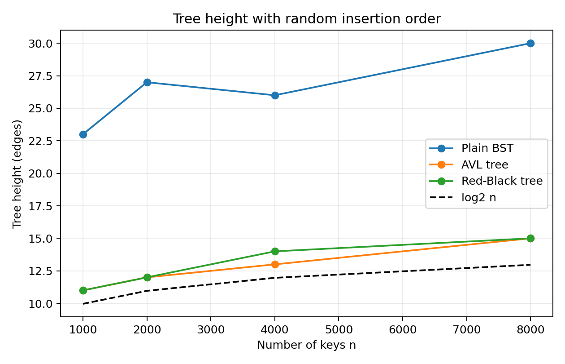
Figure 4. Heights with sorted insertion order (logarithmic y-axis).
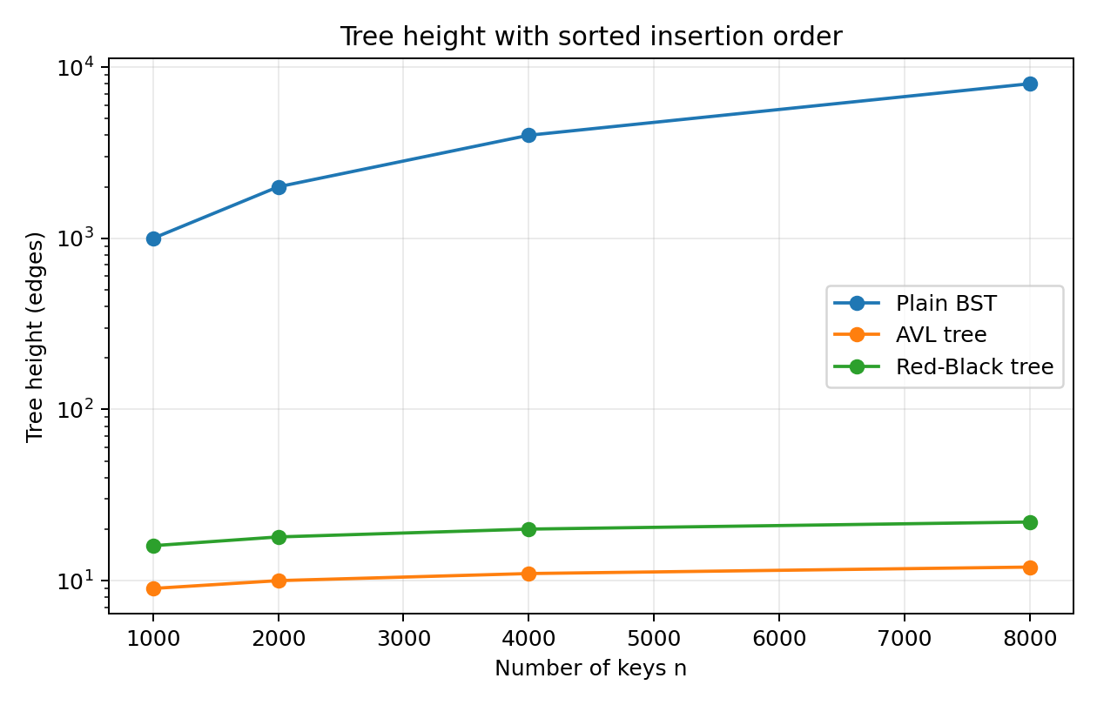

10. Deliverables and marking

What to submit
- week3_lab.py: the completed starter file. python week3_lab.py must print PASS on all four lines.
- benchmark.py: your Part E code, plus the two plots as PNG files.
- The completed results sheet (Section 9), as a scan, photo or typed PDF.
- Optional: leaderboard.py and a half-page write-up for the mini challenge.

Rubric
Component | Marks | Full marks require
Part A | 15 | Iterative insert, search and height; correct Table 1; correct explanation of the RecursionError
Part B | 10 | Both rotations pass the test; correct paper rotation and in-order argument
Part C | 30 | Correct trace and final tree; complete N(h) table and height bound; AVL passes sorted and random tests; validator checks order, heights and BF
Part D | 15 | All four trees classified with the right property; correct trace with case names; validator returns correct results
Part E | 20 | Harness is correct and fair; complete table; two labelled plots; answers connect results to big-O and constant factors
Report | 10 | Clear, complete, neatly presented; code is readable and commented
Challenge | +10 | size maintained through rotations and deletion; select and rank in O(log n); both leaderboards agree; scaling measured and explained

ACADEMIC INTEGRITY
You may discuss ideas, but every line of code you submit must be written by you. If you use an outside source, cite it in a comment.

Appendix A. Starter code: week3_lab_starter.py
Complete every function marked TODO. Do not edit the test functions at the bottom.
"""Week 3 Lab - Advanced Trees: starter code.

Fill in every function marked TODO. Run this file to test your work:
python week3_lab_starter.py
Each test prints PASS, FAIL or TODO. Do not change the test functions.
"""
import bisect
import random
import sys
import time

sys.setrecursionlimit(10000)

# ========================================================
# Part A: plain BST

class BSTNode:
def __init__(self, key):
self.key = key
self.left = None
self.right = None
class BST:
def __init__(self):
self.root = None
def insert(self, key):
new_node = BSTNode(key)
if self.root is None:
self.root = new_node
return
current = self.root
while True:
if key == current.key:
return
if key < current.key:
if current.left is None:
current.left = new_node
return
current = current.left
else:
if current.right is None:
current.right = new_node
return
current = current.right

def search(self, key):
current = self.root
while current is not None:
if key == current.key:
return True
if key < current.key:
current = current.left
else:
current = current.right
return False

def height(self):
if self.root is None:
return -1
stack = [(self.root, 0)]
largest = 0
while stack:
node, depth = stack.pop()
if depth > largest:
largest = depth
if node.left is not None:
stack.append((node.left, depth + 1))
if node.right is not None:
stack.append((node.right, depth + 1))
return largest

# ========================================================
# Part B: rotations

def rotate_left(x):
y = x.right
x.right = y.left
y.left = x
return y

def rotate_right(y):
x = y.left
y.left = x.right
x.right = y
return x

# ========================================================
# Part C: AVL tree

class AVLNode:
def __init__(self, key):
self.key = key
self.left = None
self.right = None
self.height = 0

def h(node):
return node.height if node else -1

def update(node):
node.height = 1 + max(h(node.left), h(node.right))

def balance(node):
return h(node.left) - h(node.right)

class AVLTree:
def __init__(self):
self.root = None
self.rotations = 0

def rotate_left(self, x):
y = x.right
x.right = y.left
y.left = x
update(x)
update(y)
self.rotations += 1
return y

def rotate_right(self, y):
x = y.left
y.left = x.right
x.right = y
update(y)
update(x)
self.rotations += 1
return x

def rebalance(self, node):
update(node)
bf = balance(node)
if bf > 1:
if balance(node.left) < 0:
node.left = self.rotate_left(node.left)
return self.rotate_right(node)
if bf < -1:
if balance(node.right) > 0:
node.right = self.rotate_right(node.right)
return self.rotate_left(node)
return node

def insert(self, key):
self.root = self._insert(self.root, key)

def _insert(self, node, key):
if node is None:
return AVLNode(key)
if key < node.key:
node.left = self._insert(node.left, key)
elif key > node.key:
node.right = self._insert(node.right, key)
else:
return node
return self.rebalance(node)

def search(self, key):
cur = self.root
while cur:
if key == cur.key:
return True
cur = cur.left if key < cur.key else cur.right
return False

def height(self):
return h(self.root)

def is_valid(self):
def check(node, low, high):
if node is None:
return True
if low is not None and node.key <= low:
return False
if high is not None and node.key >= high:
return False

correct_height = 1 + max(
h(node.left),
h(node.right)
)

if node.height != correct_height:
return False
bf = balance(node)
if bf < -1 or bf > 1:
return False
if not check(node.left, low, node.key):
return False
if not check(node.right, node.key, high):
return False
return True
return check(self.root, None, None)

# ========================================================
# Part D: Red-Black validator

# A Red-Black tree is given as nested tuples: (key, colour, left, right)
# where colour is "R" or "B" and an empty child (NIL) is None.

def is_valid_rb(t):
if t is None:
return True, 1
if t[1] != "B":
return False, "root must be black"

def check(node, low, high):
if node is None:
return 1
key, color, left, right = node
if low is not None and key <= low:
raise ValueError("BST order broken")
if high is not None and key >= high:
raise ValueError("BST order broken")
if color == "R":
if left is not None and left[1] == "R":
raise ValueError("red node has red child")
if right is not None and right[1] == "R":
raise ValueError("red node has red child")
left_black_height = check(left,low,key)
right_black_height = check(right,key,high)
if left_black_height != right_black_height:
raise ValueError("black-height mismatch")
if color == "B":
return left_black_height + 1
return left_black_height

try:
black_height = check(t,None,None)
return True, black_height
except ValueError as e:
return False, str(e)

# ======================================================== tests (do not edit)

def run(name, fn):
try:
fn()
print(f"PASS {name}")
except NotImplementedError:
print(f"TODO {name}")
except AssertionError as e:
print(f"FAIL {name} {e}")

def inorder(n, out):
if n:
inorder(n.left, out)
out.append(n.key)
inorder(n.right, out)
return out

def test_bst():
t = BST()

for k in range(2000):
t.insert(k)

assert t.height() == 1999, "sorted input should give a chain"
assert t.search(1234) and not t.search(5000)

def test_rotations():
rng = random.Random(0)

for _ in range(100):
t = BST()

for k in rng.sample(range(500), 40):
t.insert(k)

before = inorder(t.root, [])

t.root = rotate_left(t.root) if t.root.right else rotate_right(t.root)

assert inorder(t.root, []) == before, "rotation changed the in-order sequence"

def test_avl():
rng = random.Random(1)

for order in ("sorted", "random"):

keys = list(range(3000))

if order == "random":
rng.shuffle(keys)

t = AVLTree()

for k in keys:
t.insert(k)

assert t.is_valid(), f"invalid AVL tree ({order} input)"
assert t.height() <= 1.44 * 11.56 + 1, "AVL tree too tall"

def test_rb():
good = (
13,
"B",
(
8,
"R",
(1, "B", None, None),
(11, "B", None, None)
),
(
17,
"R",
(15, "B", None, None),
(25, "B", None, None)
)
)

red_red = (
20,
"B",
(10, "B", None, None),
(
30,
"B",
(
25,
"R",
None,
(27, "R", None, None)
),
None
)
)

assert is_valid_rb(good) == (
True,
3
), "tree 1 is valid with black-height 3 (counting NIL)"

assert is_valid_rb(red_red)[0] is False, \
"tree 2 has a red node with a red child"

if __name__ == "__main__":
run(
"Part A BST on 2,000 sorted keys",
test_bst
)

run(
"Part B rotations keep in-order",
test_rotations
)

run(
"Part C AVL insert + validator",
test_avl
)

run(
"Part D Red-Black validator",
test_rb
)

Appendix B. Reference Red-Black tree: rbtree.py
Provided for Part E and the mini challenge. Read _fix_insert and match each branch to Cases 1, 2 and 3 from the lecture.
"""Week 3 Lab - reference Red-Black tree (CLRS insertion, sentinel NIL).

Provided for Part E and the mini challenge. You do not need to modify it.
from rbtree import RBTree
t = RBTree(); t.insert(5); t.search(5); t.height(); t.is_valid()
"""

# ------------------------------------------------------------------ Red-Black
RED, BLACK = 0, 1

class RBNode:
__slots__ = ("key", "color", "left", "right", "parent")

def __init__(self, key, color, nil):
self.key = key
self.color = color
self.left = nil
self.right = nil
self.parent = nil

class RBTree:
"""Red-Black tree following CLRS (sentinel NIL node)."""

def __init__(self):
self.NIL = RBNode(None, BLACK, None)
self.NIL.left = self.NIL.right = self.NIL.parent = self.NIL
self.root = self.NIL
self.rotations = 0
self.recolors = 0

def rotate_left(self, x):
y = x.right
x.right = y.left
if y.left is not self.NIL:
y.left.parent = x
y.parent = x.parent
if x.parent is self.NIL:
self.root = y
elif x is x.parent.left:
x.parent.left = y
else:
x.parent.right = y
y.left = x
x.parent = y
self.rotations += 1

def rotate_right(self, y):
x = y.left
y.left = x.right
if x.right is not self.NIL:
x.right.parent = y
x.parent = y.parent
if y.parent is self.NIL:
self.root = x
elif y is y.parent.right:
y.parent.right = x
else:
y.parent.left = x
x.right = y
y.parent = x
self.rotations += 1

def insert(self, key):
parent, cur = self.NIL, self.root
while cur is not self.NIL:
parent = cur
if key < cur.key:
cur = cur.left
elif key > cur.key:
cur = cur.right
else:
return # duplicate
z = RBNode(key, RED, self.NIL)
z.parent = parent
if parent is self.NIL:
self.root = z
elif key < parent.key:
parent.left = z
else:
parent.right = z
self._fix_insert(z)

def _fix_insert(self, z):
while z.parent.color == RED:
gp = z.parent.parent
if z.parent is gp.left:
uncle = gp.right
if uncle.color == RED: # Case 1: recolor
z.parent.color = BLACK
uncle.color = BLACK
gp.color = RED
self.recolors += 3
z = gp
else:
if z is z.parent.right: # Case 2: triangle
z = z.parent
self.rotate_left(z)
z.parent.color = BLACK # Case 3: line
gp.color = RED
self.recolors += 2
self.rotate_right(gp)
else: # mirror image
uncle = gp.left
if uncle.color == RED:
z.parent.color = BLACK
uncle.color = BLACK
gp.color = RED
self.recolors += 3
z = gp
else:
if z is z.parent.left:
z = z.parent
self.rotate_right(z)
z.parent.color = BLACK
gp.color = RED
self.recolors += 2
self.rotate_left(gp)
if self.root.color == RED:
self.recolors += 1
self.root.color = BLACK

def search(self, key):
cur = self.root
while cur is not self.NIL:
if key == cur.key:
return True
cur = cur.left if key < cur.key else cur.right
return False

def height(self):
def go(n):
if n is self.NIL:
return -1
return 1 + max(go(n.left), go(n.right))
return go(self.root)

def inorder(self):
out = []

def go(n):
if n is not self.NIL:
go(n.left)
out.append(n.key)
go(n.right)
go(self.root)
return out

def is_valid(self):
"""Checks the 5 red-black properties; returns black-height."""
if self.root.color != BLACK:
raise AssertionError("root must be black")

def check(n, lo, hi):
if n is self.NIL:
return 1
if (lo is not None and n.key <= lo) or (hi is not None and n.key >= hi):
raise AssertionError("BST order broken")
if n.color == RED and (n.left.color == RED or n.right.color == RED):
raise AssertionError(f"red node {n.key} has red child")
lb = check(n.left, lo, n.key)
rb = check(n.right, n.key, hi)
if lb != rb:
raise AssertionError(f"black-height mismatch at {n.key}")
return lb + (1 if n.color == BLACK else 0)
return check(self.root, None, None)

Appendix C. Quick reference
Structure | Search | Insert | Delete | Height bound | Rotations per insert
Plain BST | O(h) | O(h) | O(h) | n - 1 (worst) | 0
AVL tree | O(log n) | O(log n) | O(log n) | < 1.44 log2(n + 2) | at most 1 fix (1 or 2 rotations)
Red-Black tree | O(log n) | O(log n) | O(log n) | <= 2 log2(n + 1) | at most 2
Sorted list | O(log n) | O(n) shift | O(n) shift | n/a | n/a

Red-Black insertion case | Situation (z = new red node) | Action
Parent black | no red-red conflict | nothing to do
Case 1 | uncle is red | parent and uncle black, grandparent red; continue from the grandparent
Case 2 | uncle black, z is an inner grandchild (triangle) | rotate at the parent to make a line, then Case 3
Case 3 | uncle black, z is an outer grandchild (line) | rotate at the grandparent, swap parent and grandparent colours; done
End | root may have been coloured red | paint the root black

